EXPERIMENT-10

NAME: ZARAA JUHI SAAI K ROLL NO:240701044

AIM:
The aim is to create data visualizations, such as pie charts and bar graphs, for an inventory management system using JavaScript.

PROCEDURE:
Step 1:
Set up ur html file
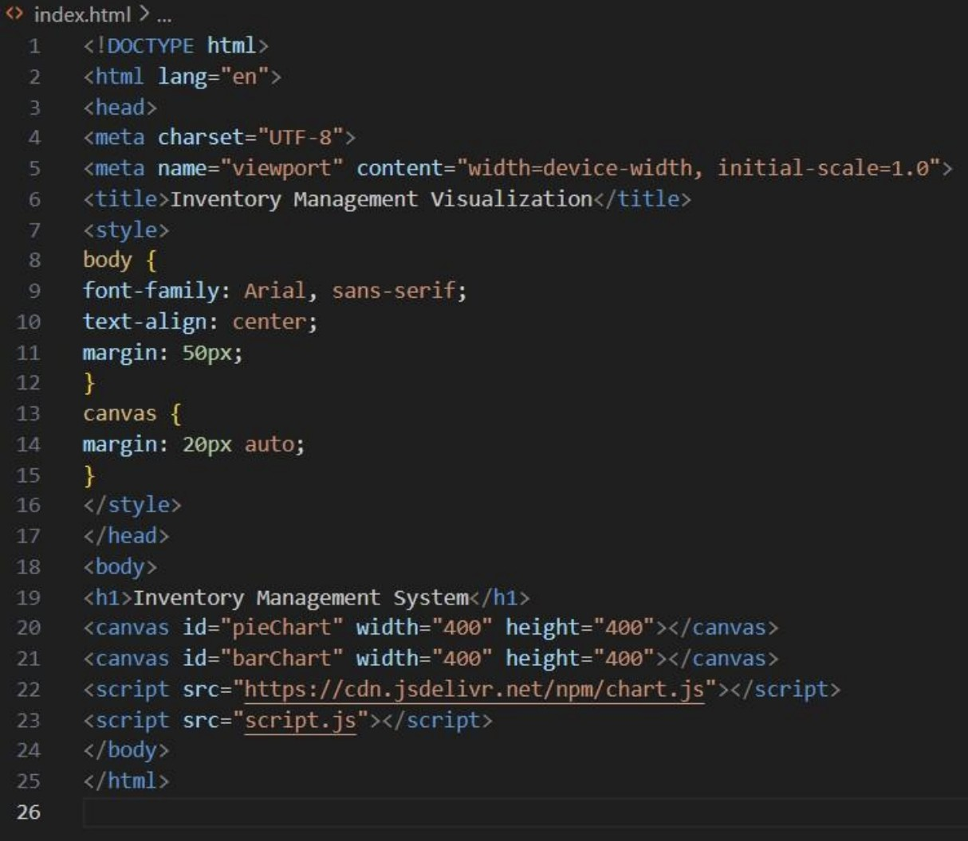

Step 2:
Create the JavaScript File for Charts Next, create a JavaScript file (script.js) to handle the data visualization logic.
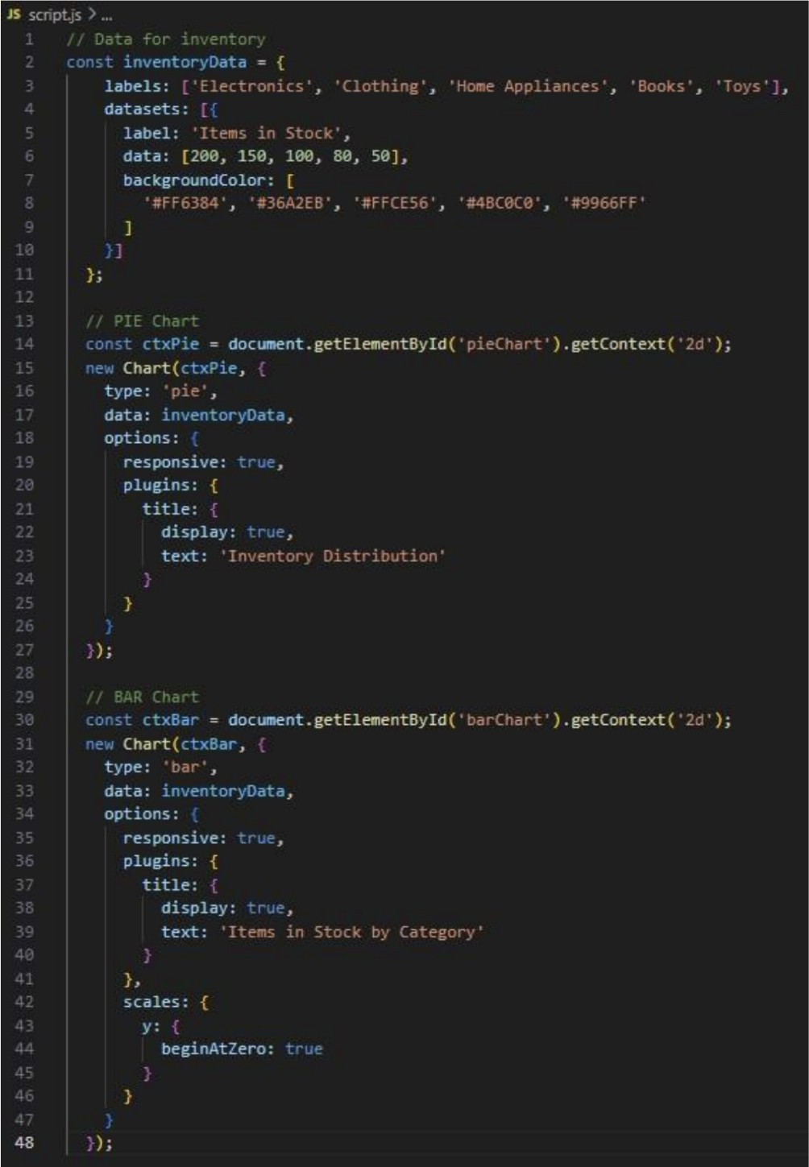

OUTPUT:

